

Experiment No.: 06

Title: Jenkins Pipeline using Domain Specific Language (DSL)
Batch: B–1 Roll No.: 16010422234 Experiment No.: 06
_____________________________________________________________________________

Aim: To create and run Jenkins pipeline using Domain Specific Language (DSL)
_____________________________________________________________________________

Resources needed: Jenkins
_____________________________________________________________________________

Theory:

Jenkins Pipeline is a combination of plugins that supports integration and implementation of continuous delivery pipelines. It has an extensible automation server to create simple and complex delivery pipelines as code via pipeline Domain Specific Language (DSL). A Pipeline is a group of events interlinked with each other in a sequence.

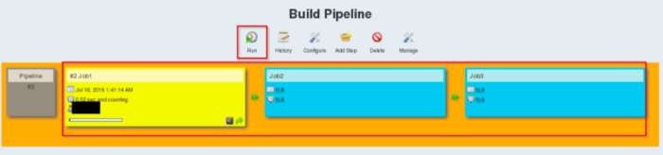

Jenkins job DSL is a plugin that allows us to define jobs in programmatic form with minimal effort. You can describe your jobs in Jenkins using a Groovy Based Language. It is similar to java but simpler because it’s much more dynamic. It is Scripting Language. Jenkins job DSL plugin was designed to make it easier to manage jobs.
_____________________________________________________________________________

Procedure:

- Install build pipeline and view pipeline
- Create sample jobs [example: build, test and Deploy].
- Create a pipeline for the sample script.
- Check the view pipeline to see the execution process.
_____________________________________________________________________________

Results: (Document with screenshots)

- All steps to install, configure pipeline
- View pipeline execution process

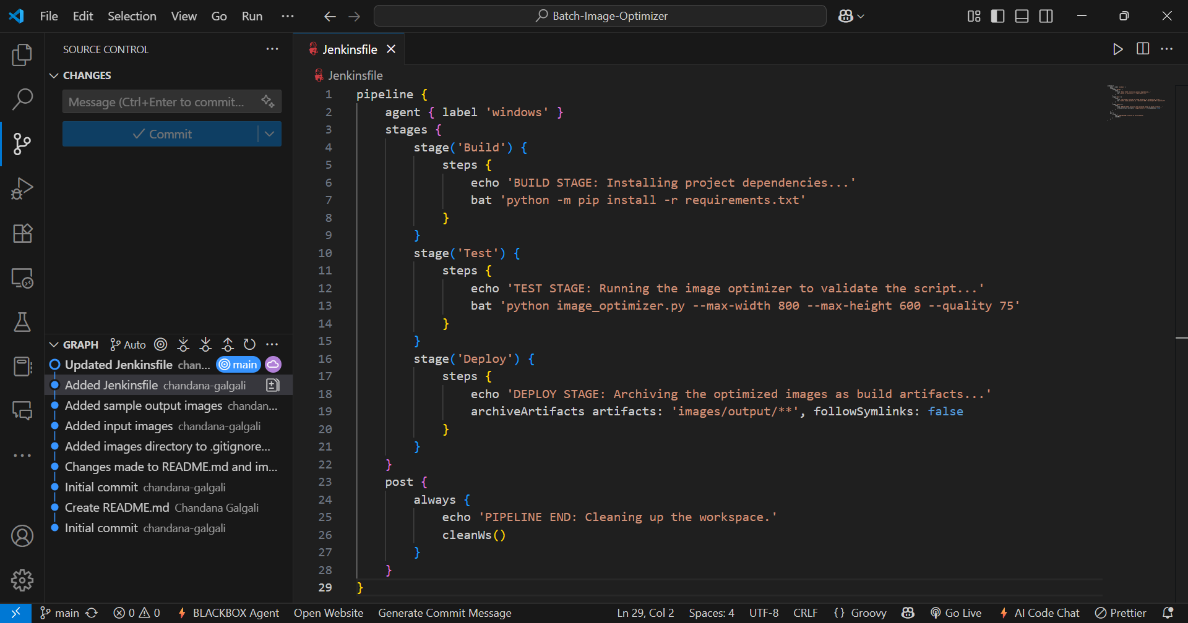

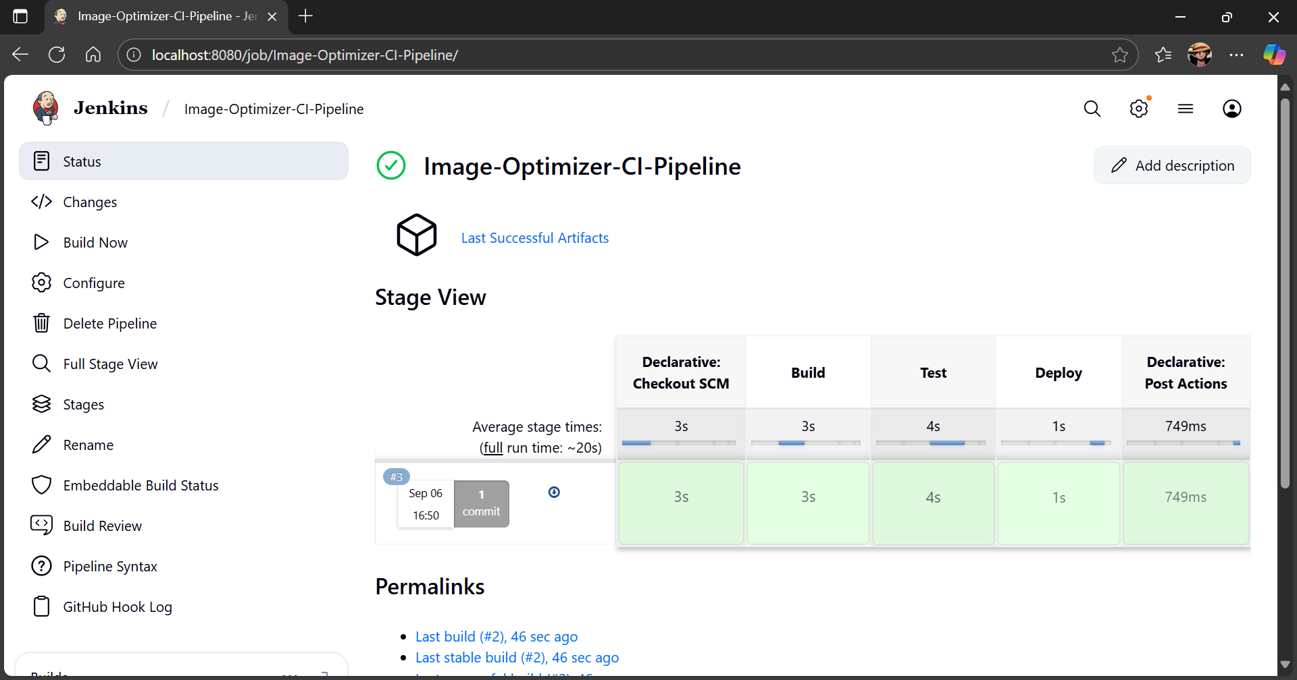

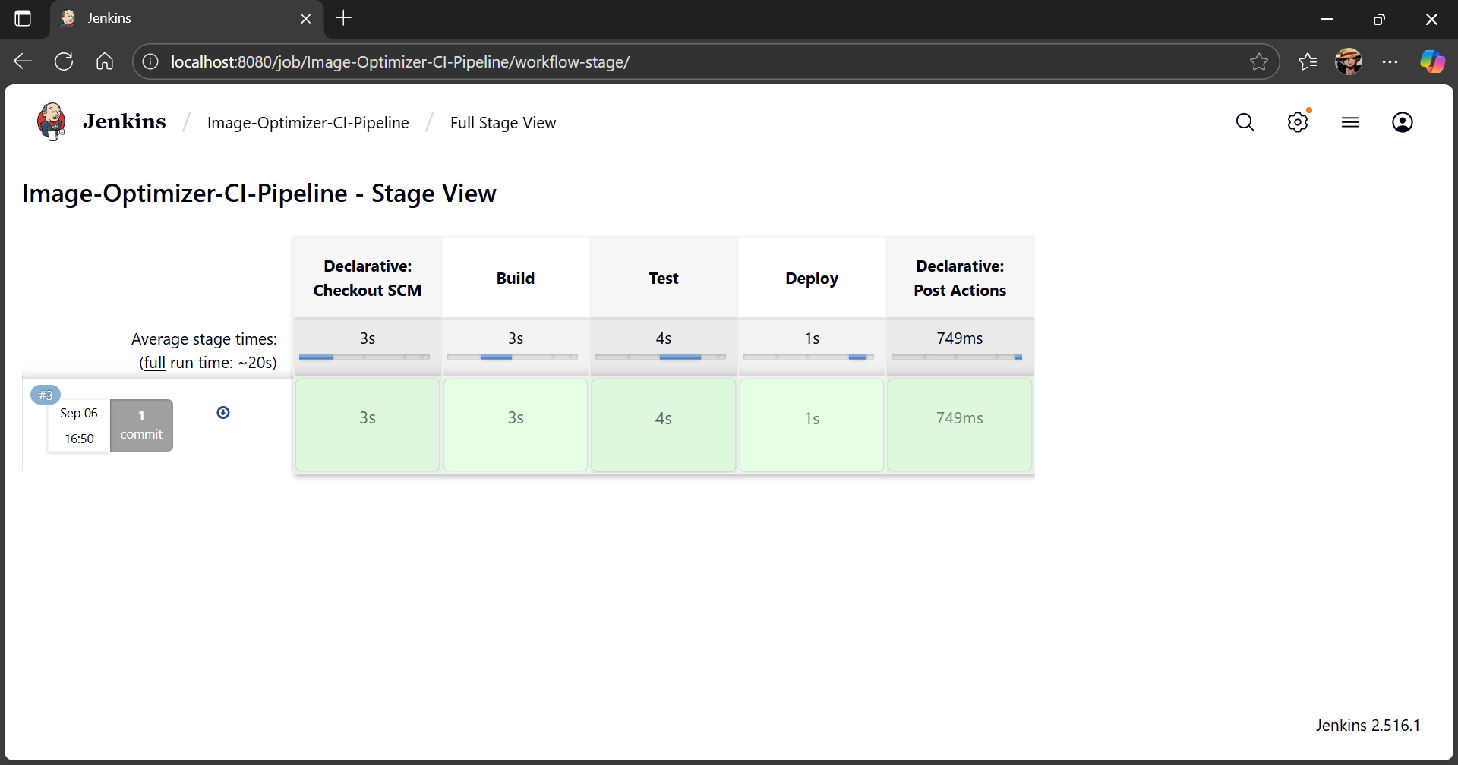

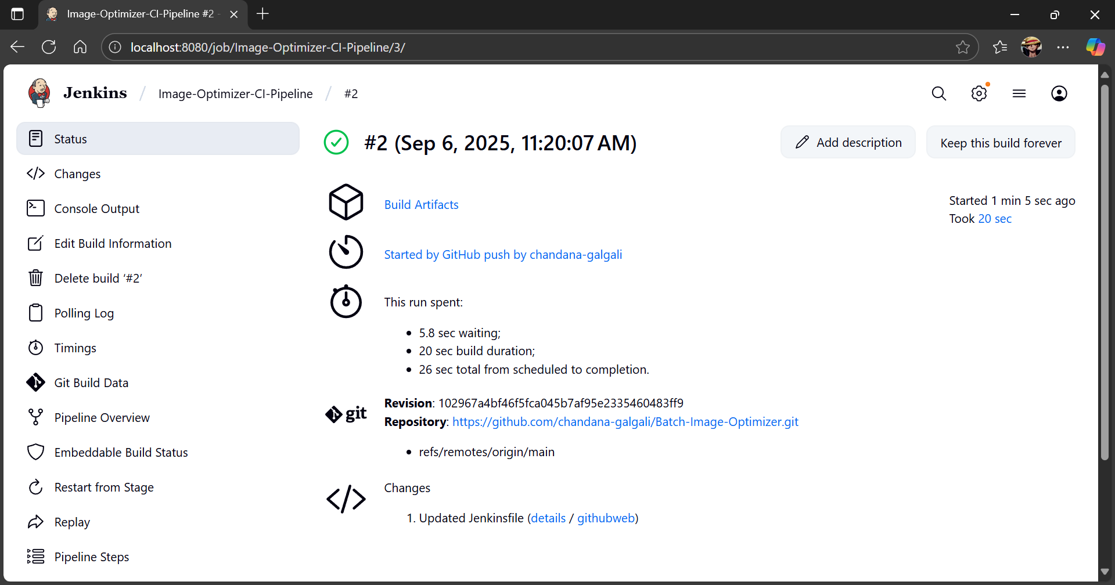

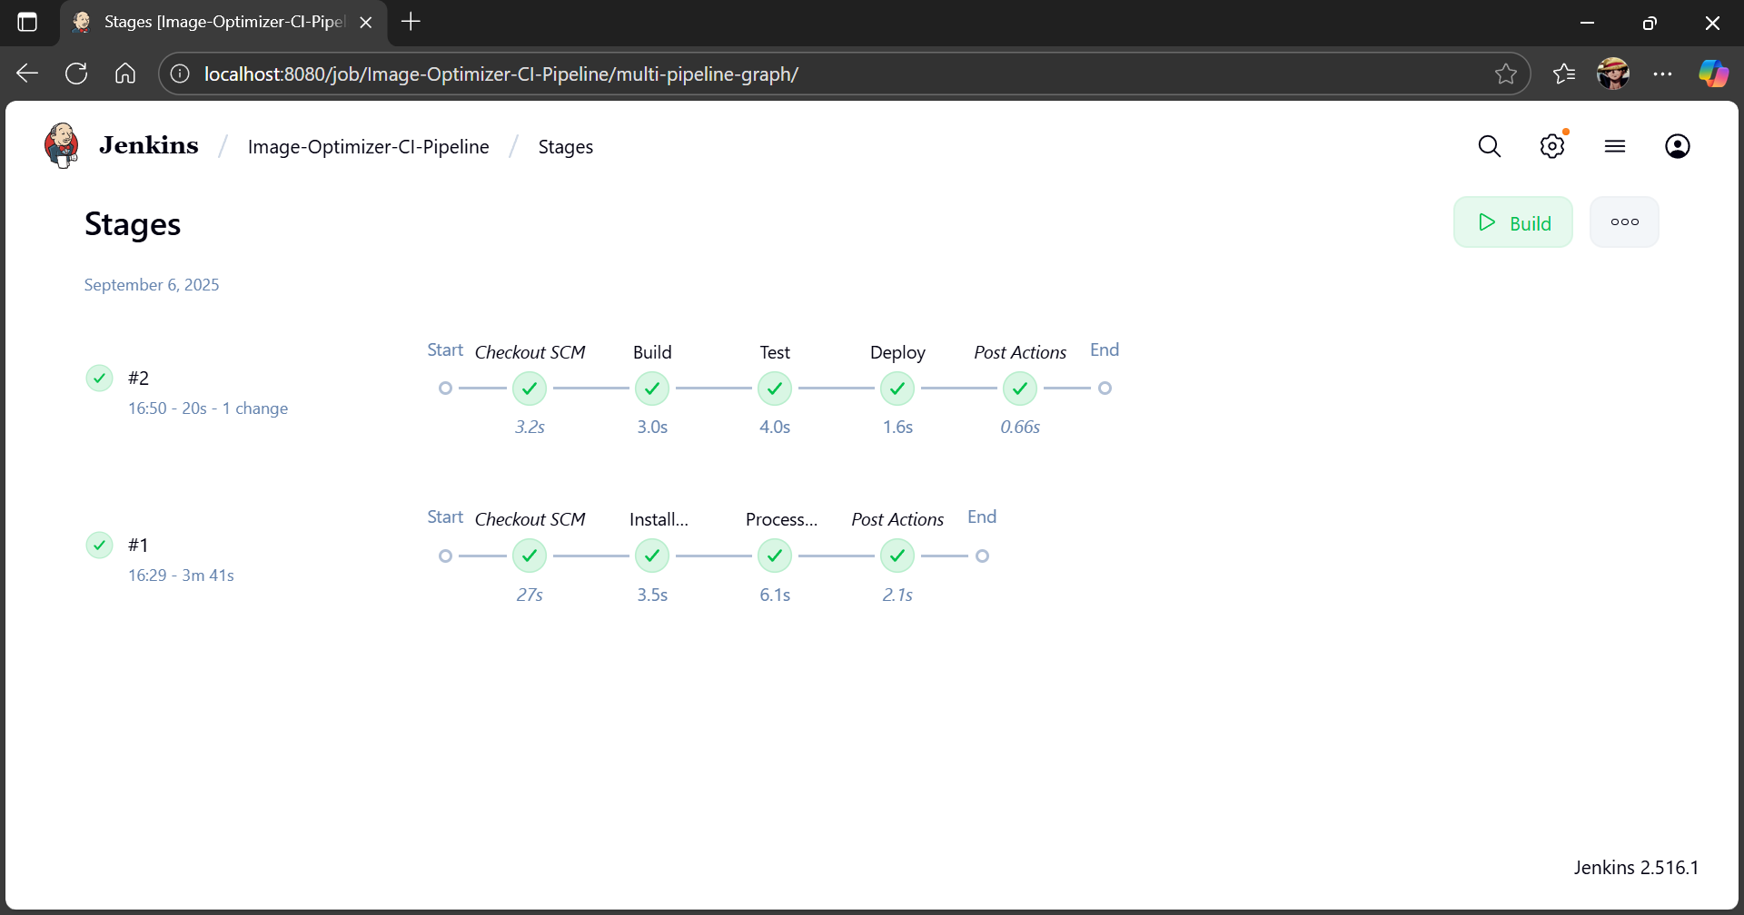

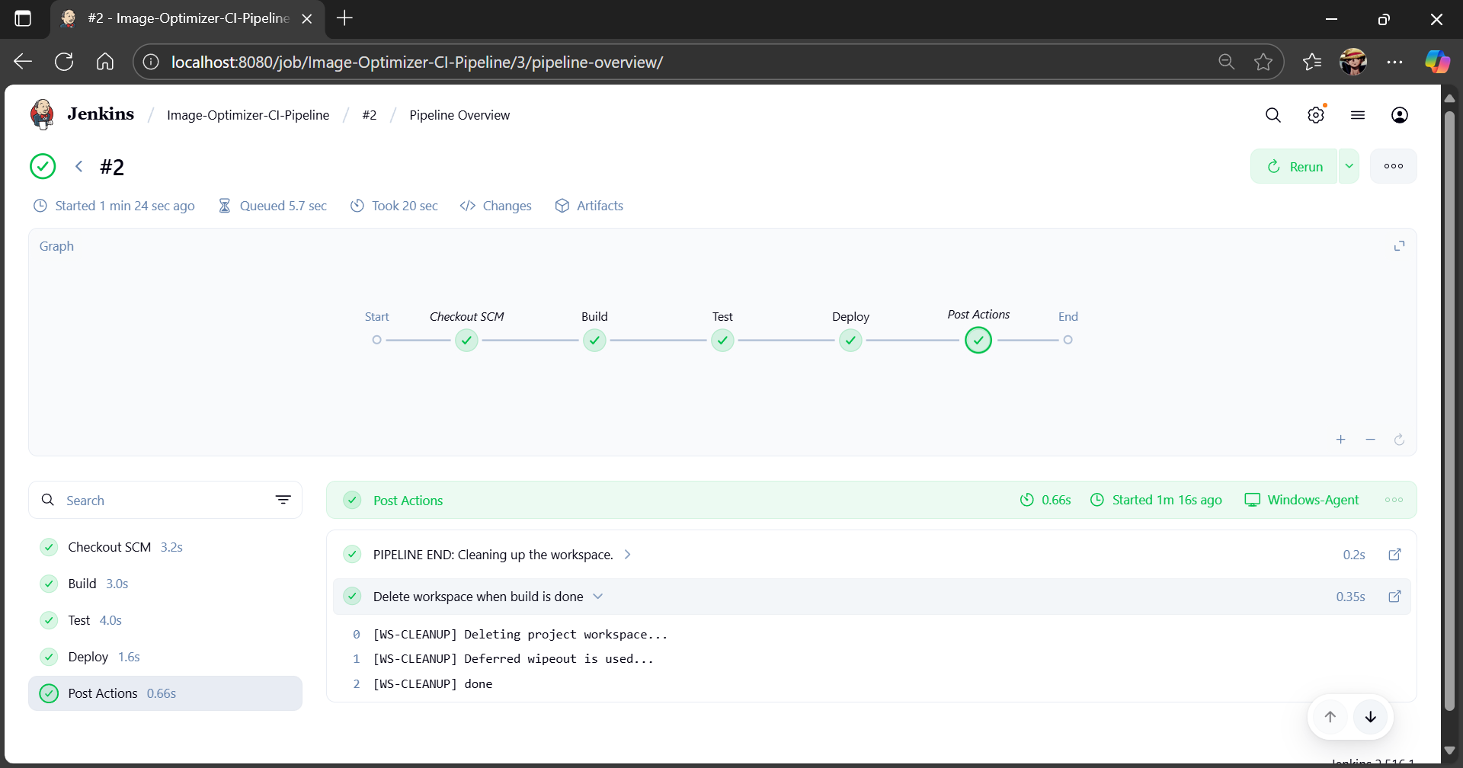

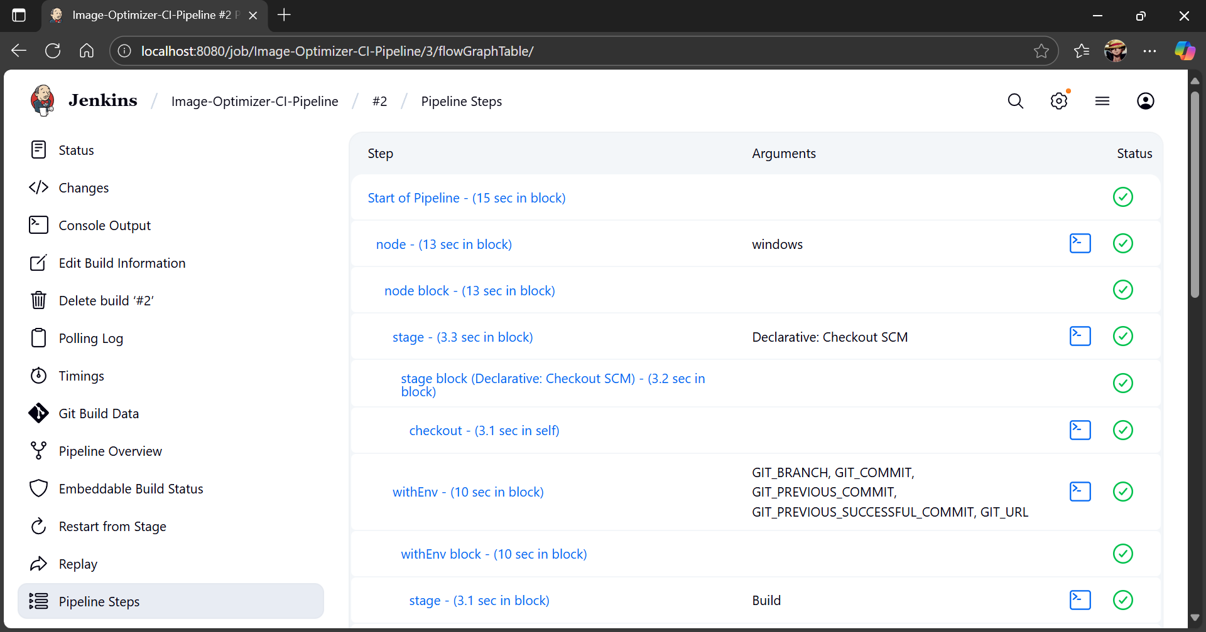

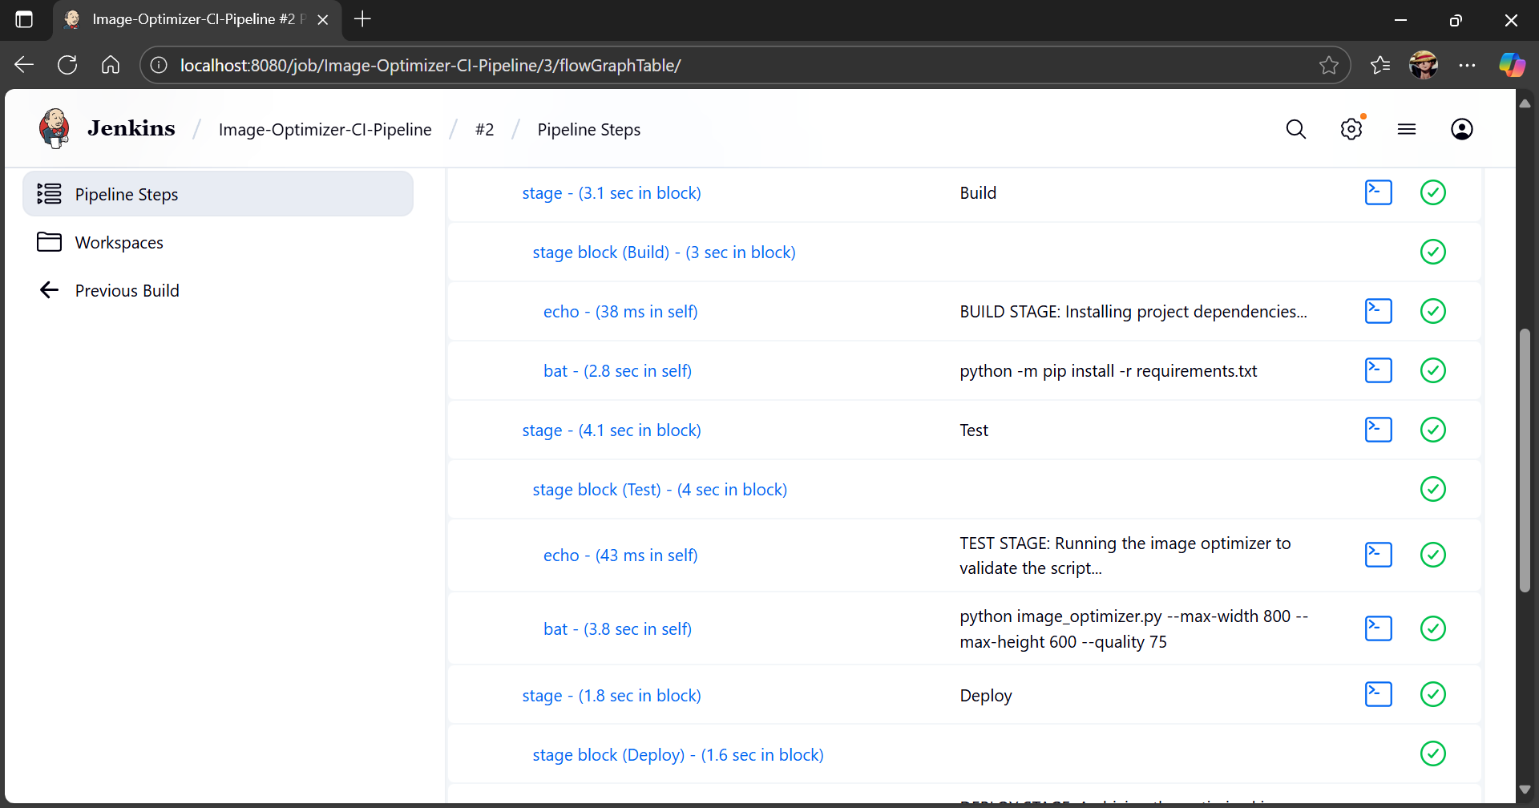

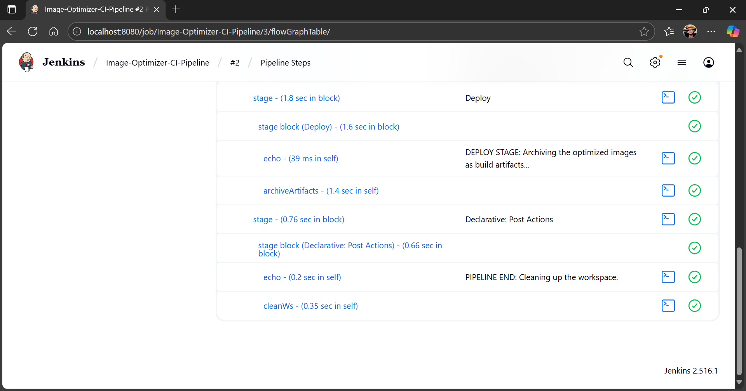
_____________________________________________________________________________

Questions:

- Explore “DevOpsDream game on https://devops.games”. DevOpsDream built as a tool for learning about what works and doesn’t work in the world of software development. The DevOpsDream is an attempt to inspire you to think about how you develop and run software. Read the instructions and play the game. Prepare a summary sheet for the same. (Understanding of concept, Snapshot of best result)

Ans: The "DevOpsDream" game is an interactive simulation that brilliantly gamifies the challenges of managing a software development project. The player takes on the role of a project lead, starting with a small team and limited features. The core goal is to deliver features to production to earn money, which can then be reinvested into hiring more developers, improving processes (like adding CI/CD or automated testing), and managing technical debt.
The game forces the player to constantly balance competing priorities:
- Feature Velocity: Should you hire more developers to release features faster and earn more money?
- Quality & Stability: Should you invest in testing and CI/D pipelines to reduce bugs and prevent production failures?
- Technical Debt: Should you spend time refactoring old code to improve long-term stability, even if it means slowing down new feature development?
Making the wrong decisions leads to cascading failures: production goes down, money is lost, developers get stressed and quit, and the project grinds to a halt. Making the right decisions leads to a stable, profitable, and efficient development lifecycle. It's a powerful and practical demonstration of core DevOps principles in action.

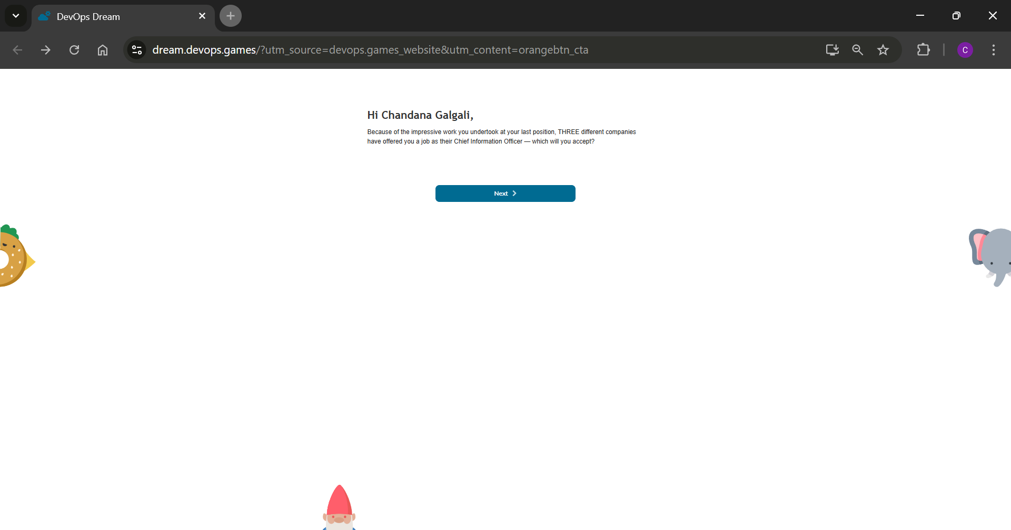

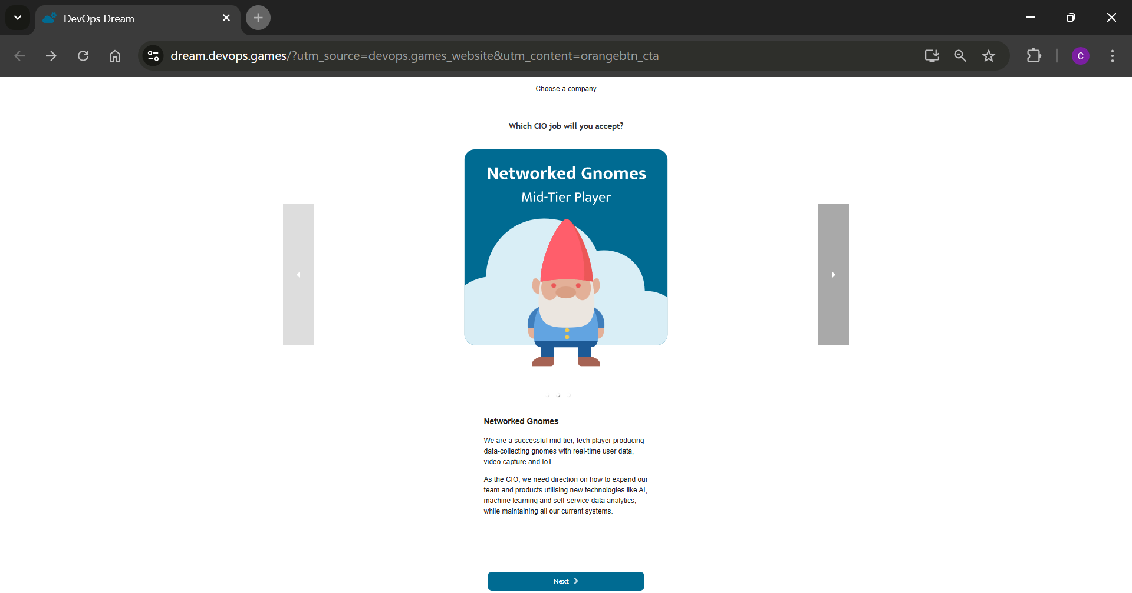

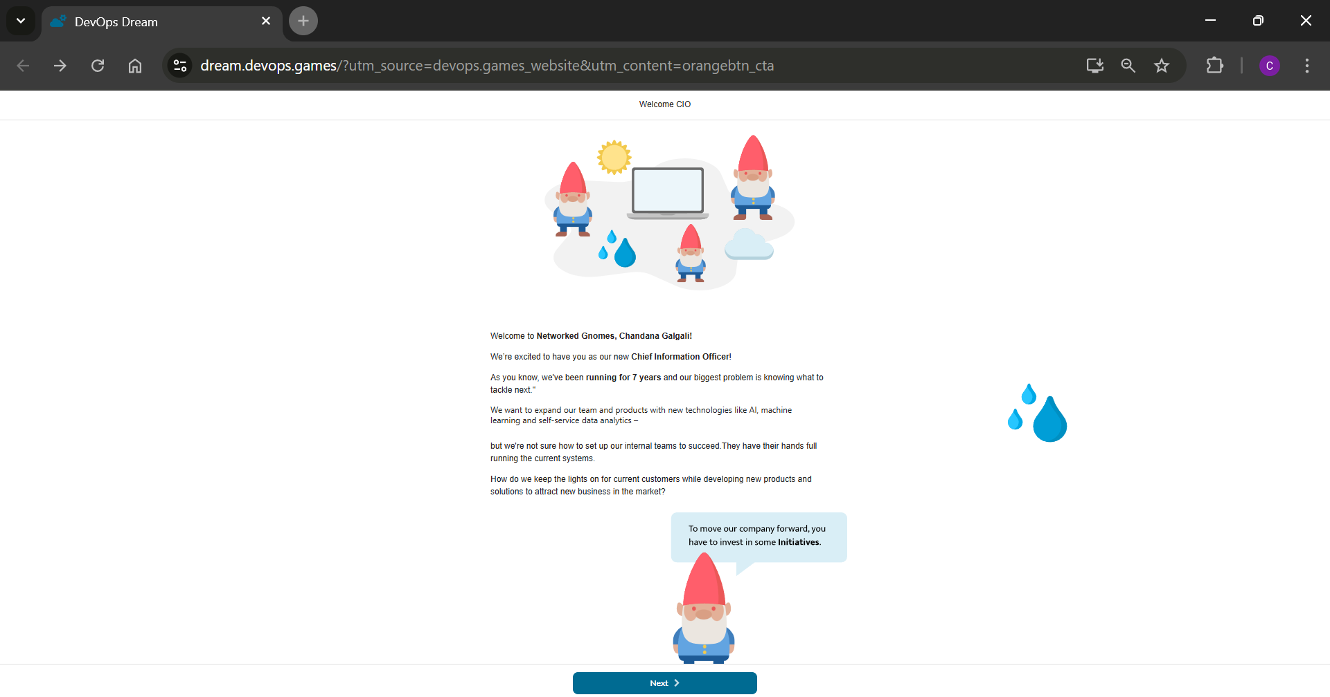

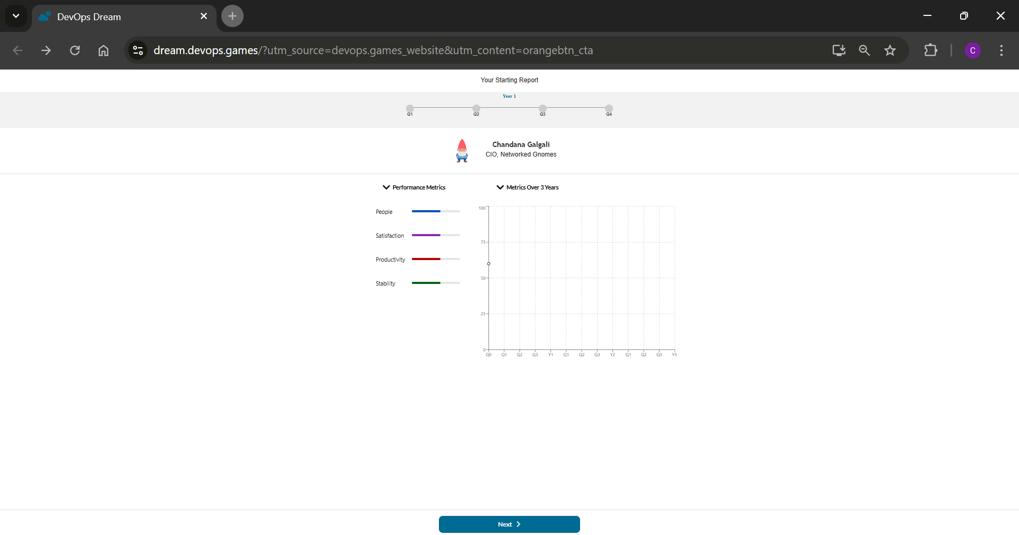

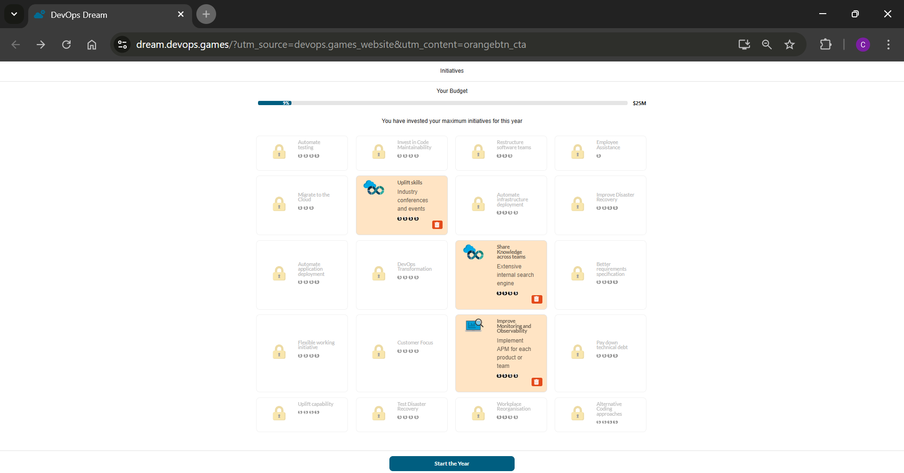

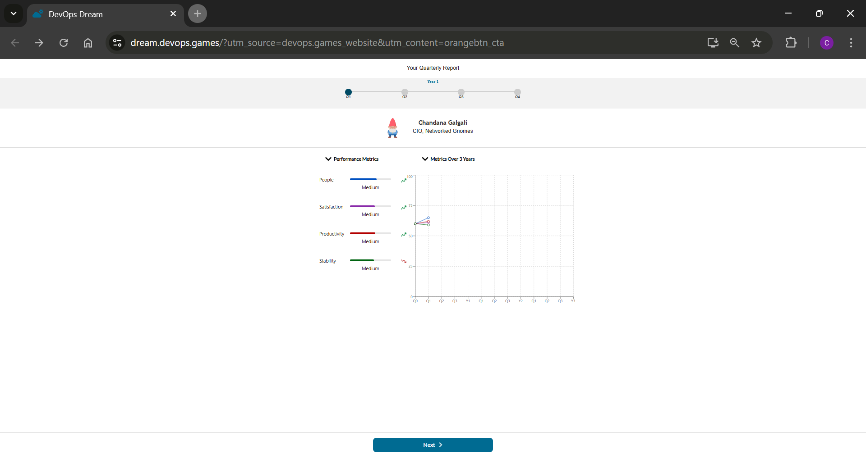

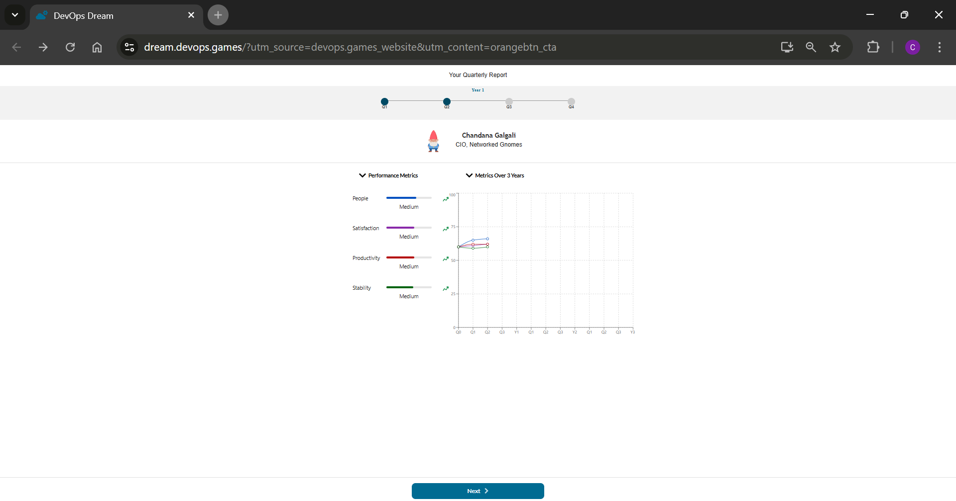

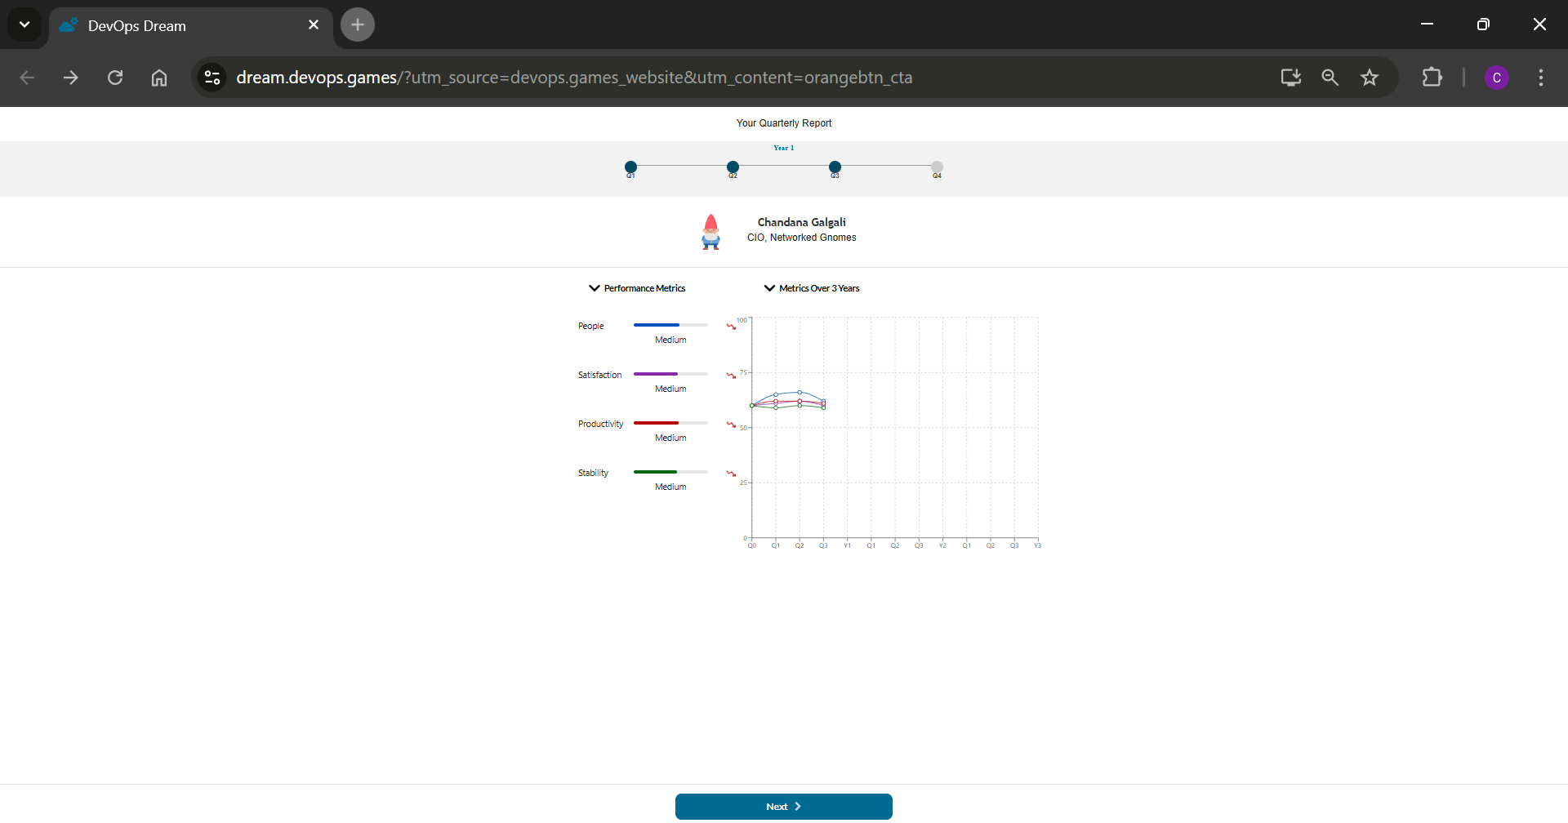

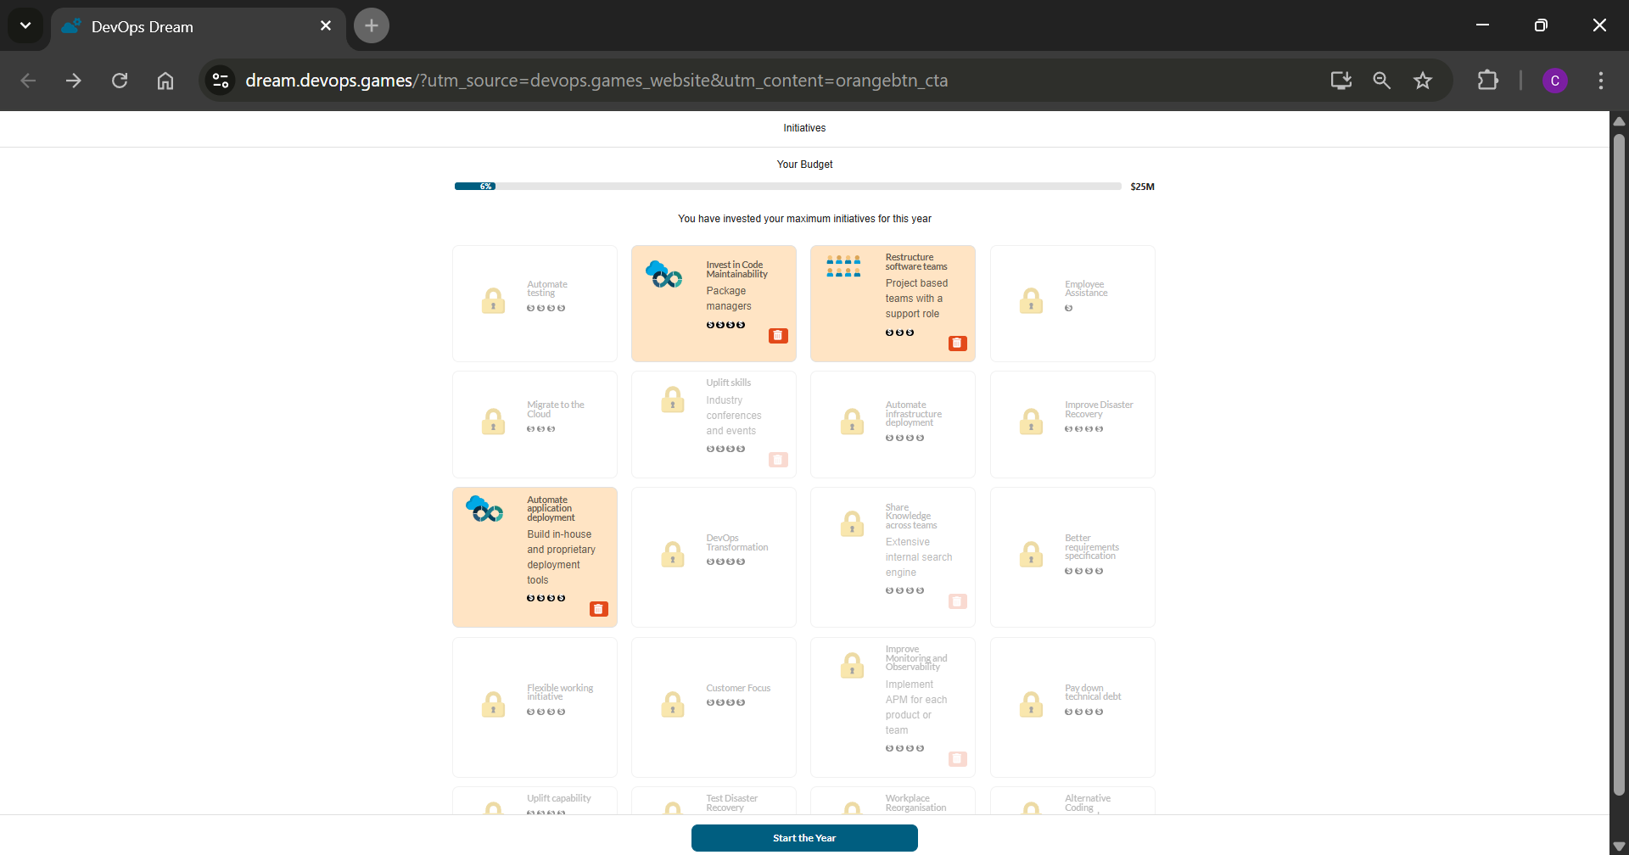



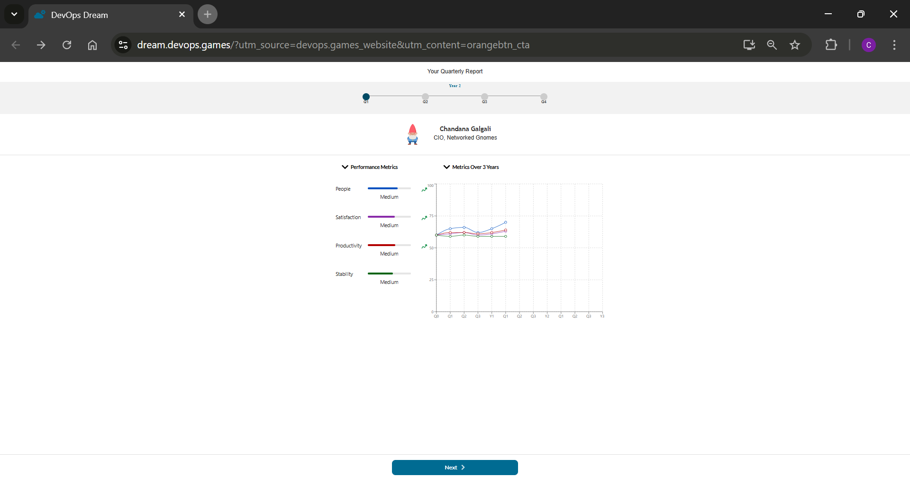

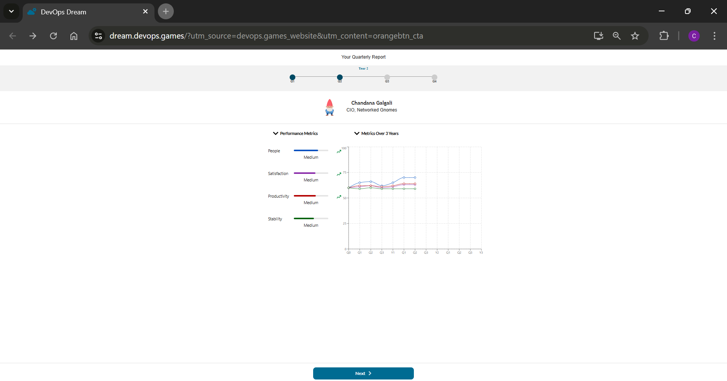

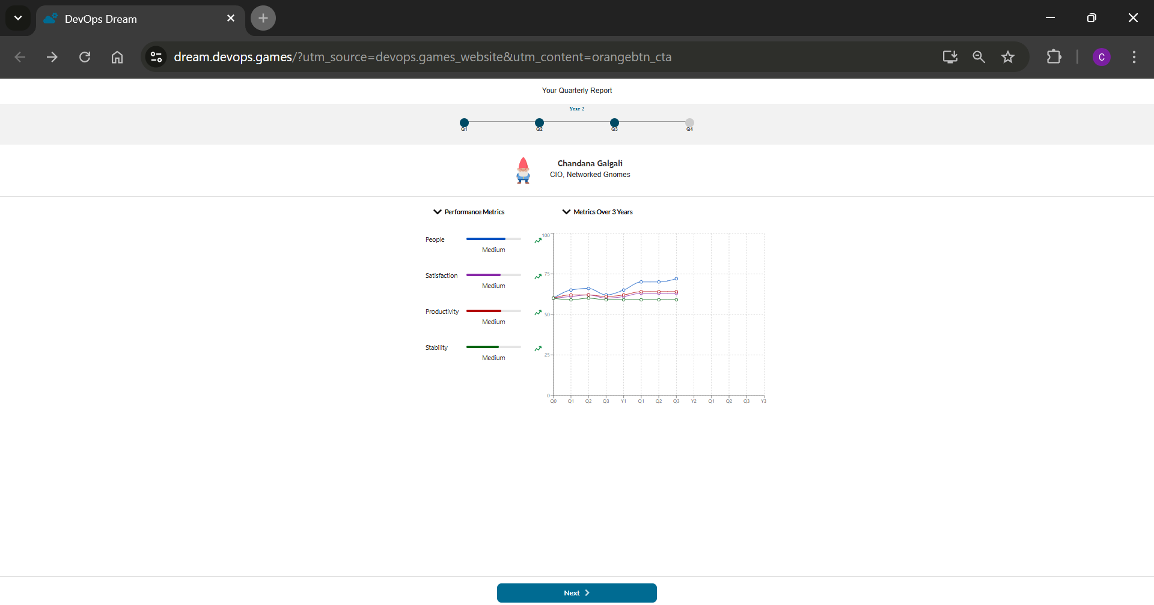

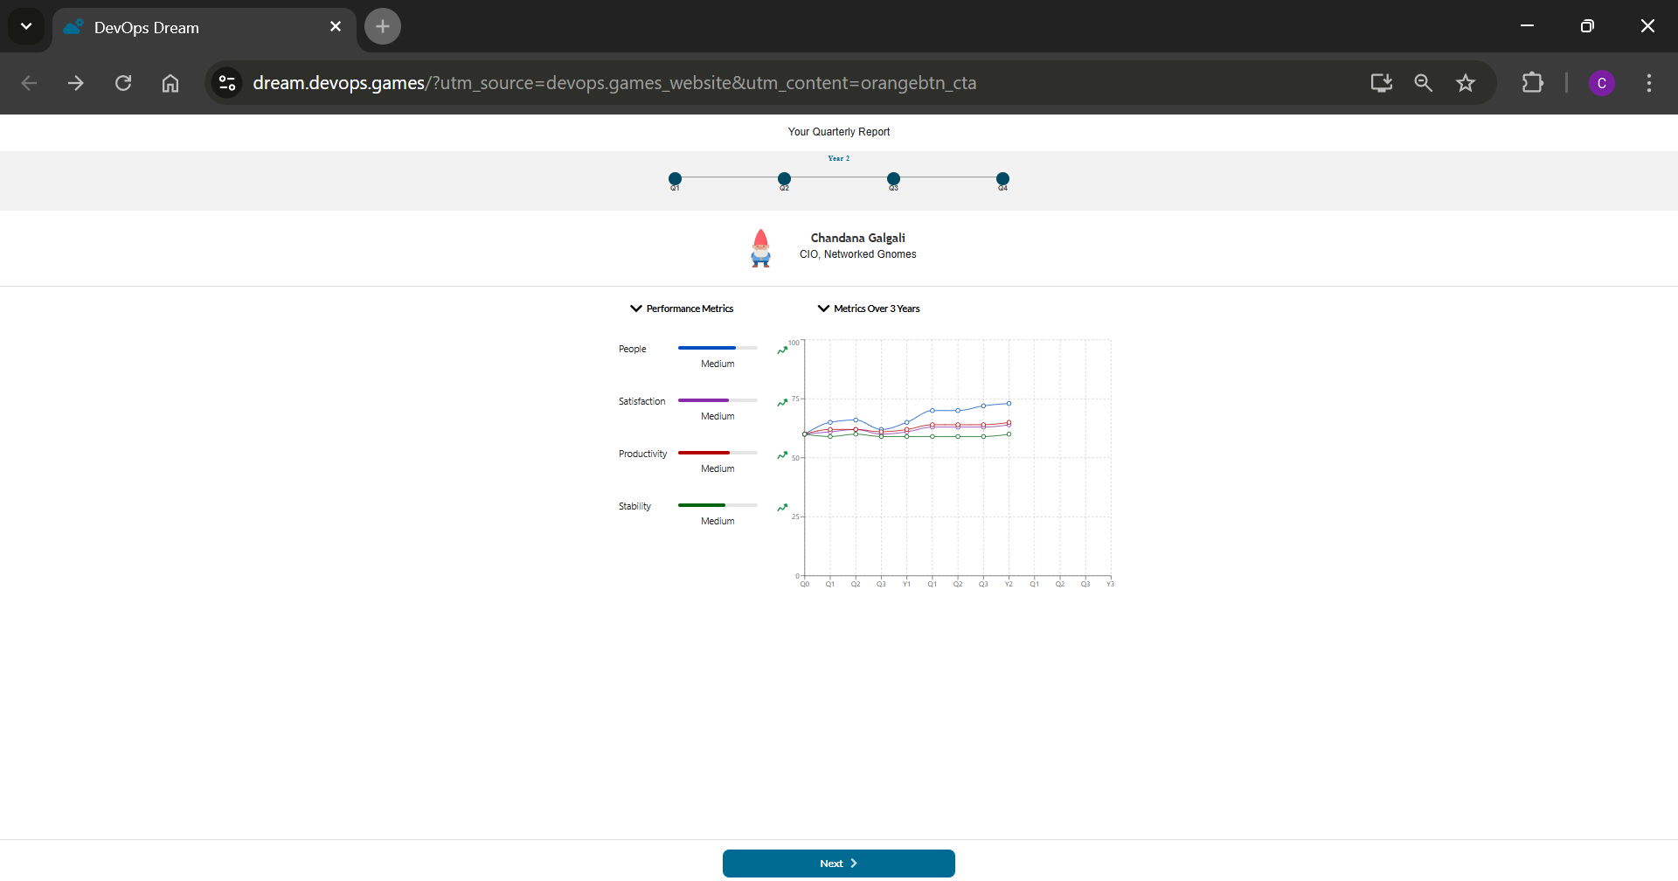

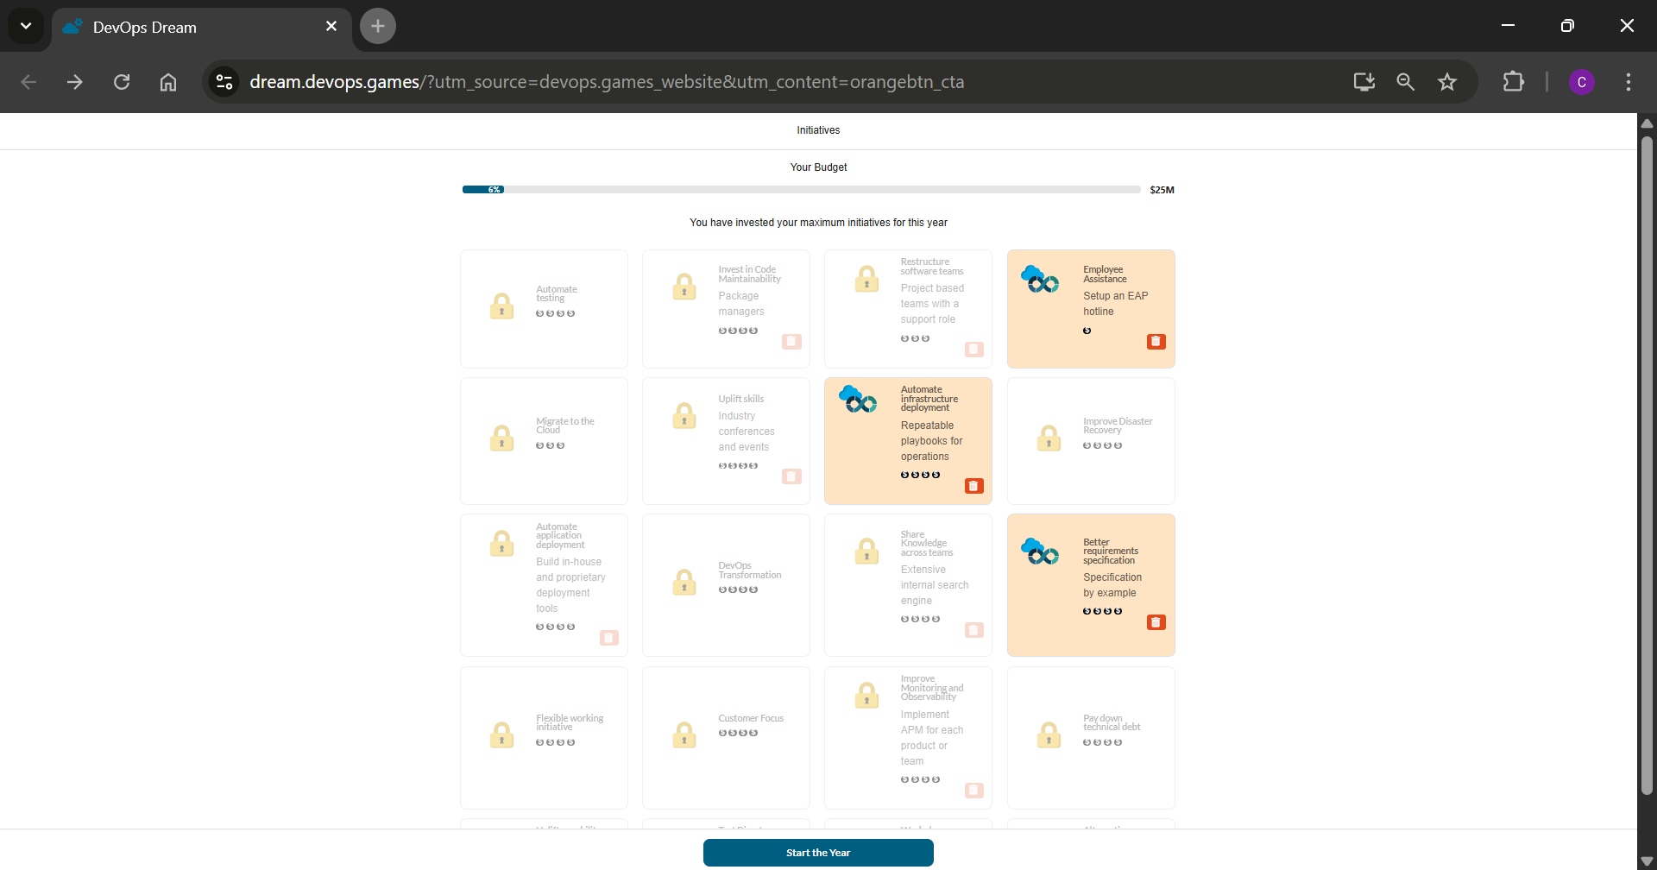

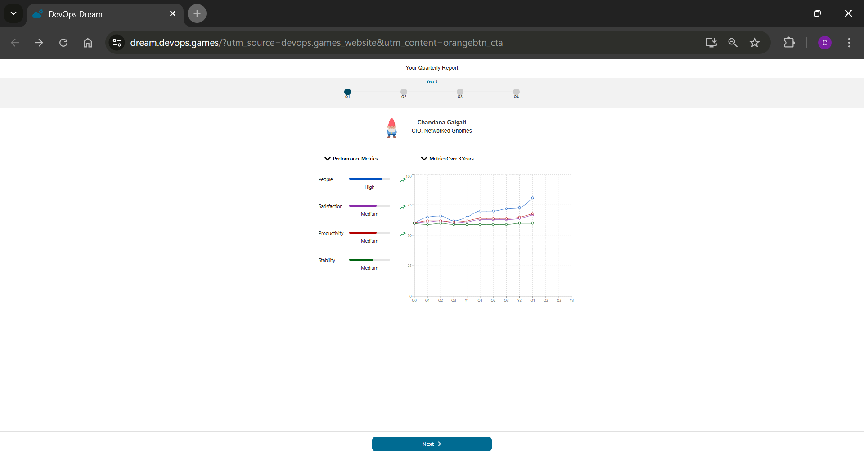

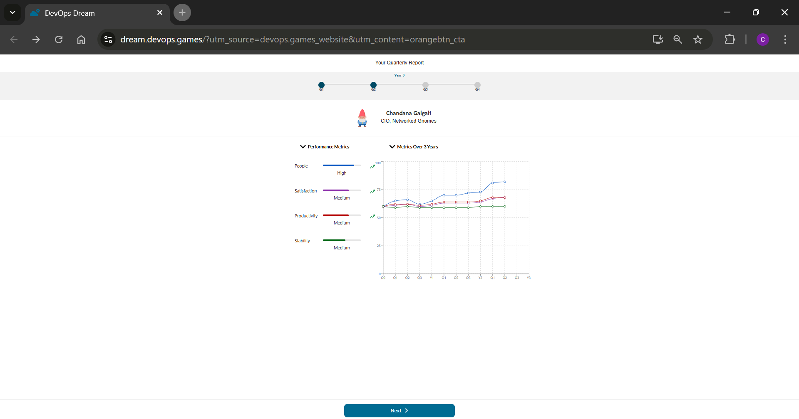

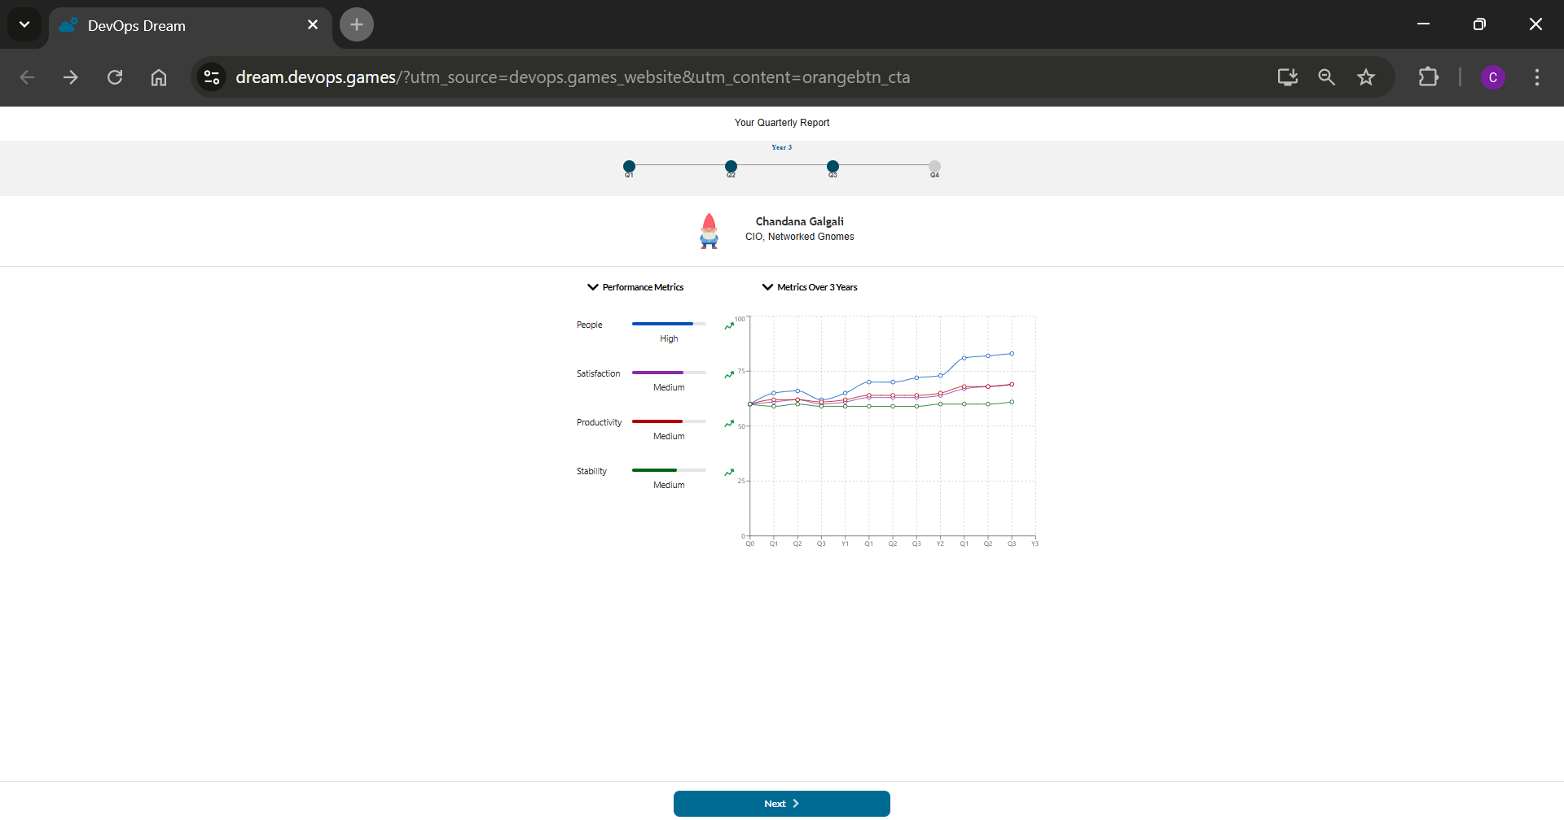

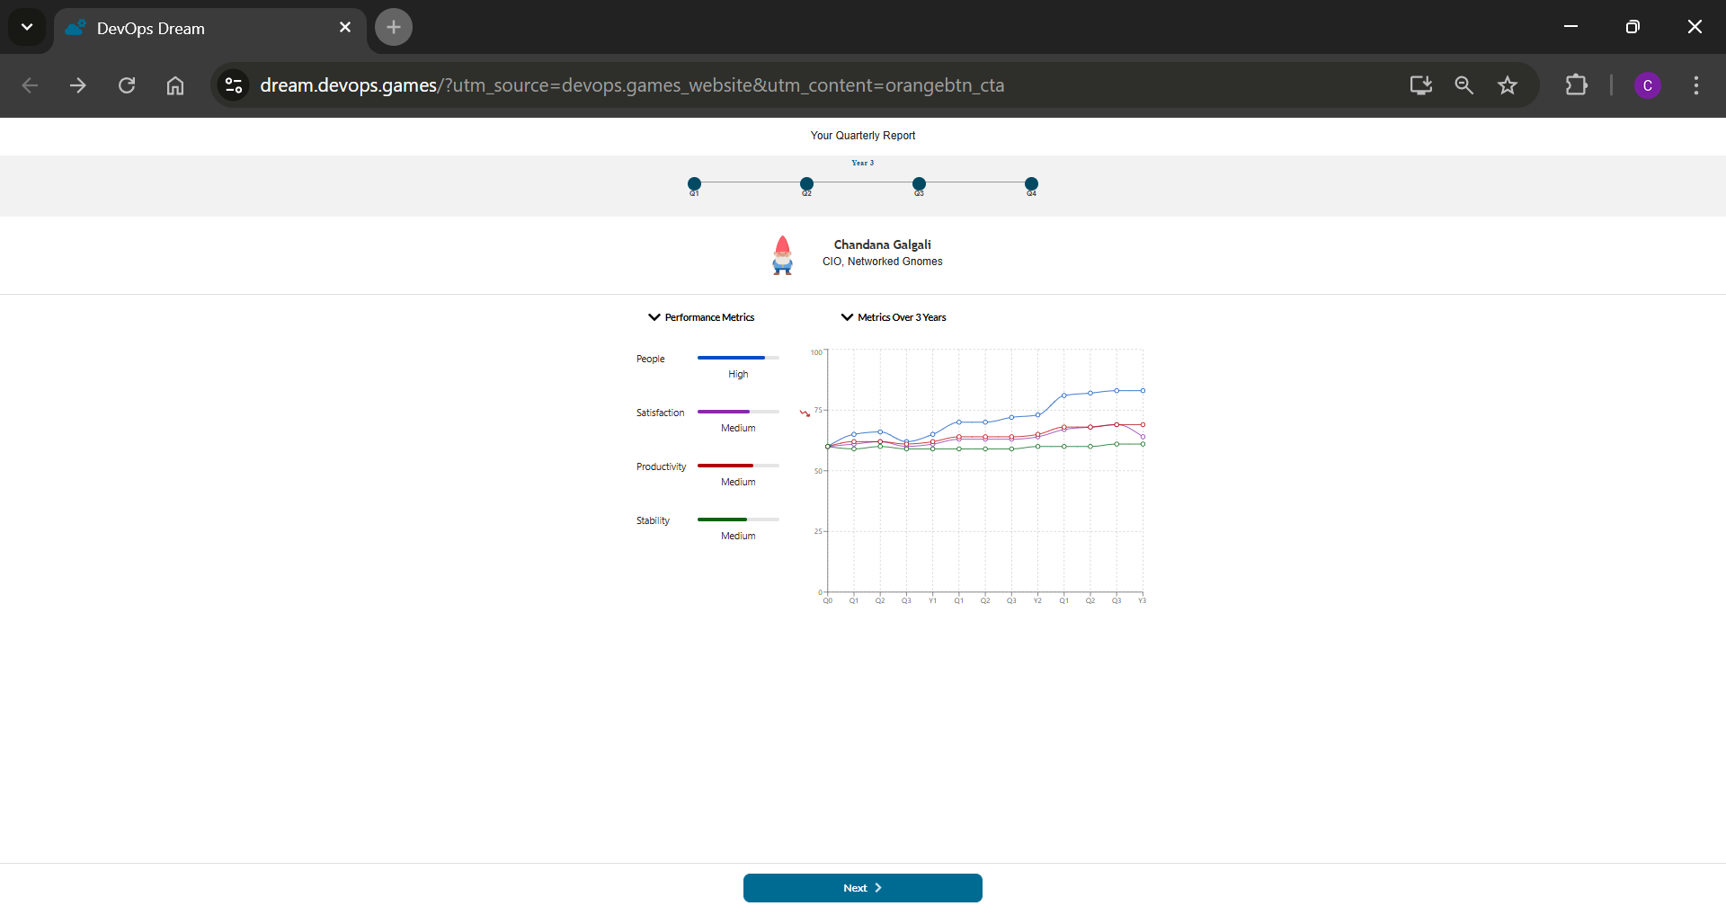

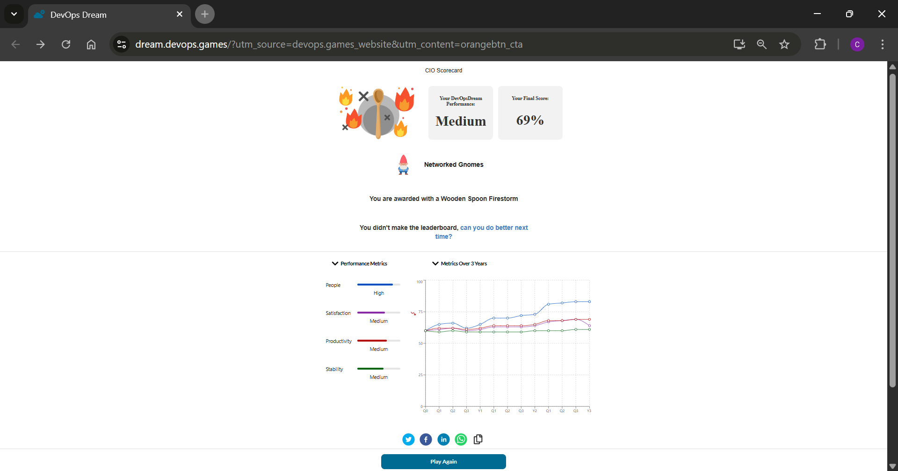

- How game based learning helps in understanding concept, logic and decision making?
Ans: Game-based learning, as demonstrated by "DevOpsDream," is highly effective for understanding complex concepts like DevOps for several key reasons:
- Safe Environment for Failure: Games provide a consequence-free sandbox. You can make a terrible decision, like hiring ten developers without any testing infrastructure, and see the entire project collapse. This failure is a powerful learning experience that you couldn't afford in the real world. You learn the why behind best practices by experiencing the negative outcomes of ignoring them.
- Immediate Feedback Loops: In a game, the consequences of your decisions are immediate. When you invest in a CI/CD pipeline, you instantly see the rate of bugs go down. When you ignore technical debt, you see production failures increase. This rapid cause-and-effect relationship makes abstract concepts tangible and easy to grasp.
- Active Engagement vs. Passive Learning: Instead of just reading about the benefits of CI/CD, the game forces you to actively decide when and how to implement it. This active participation engages critical thinking and problem-solving skills, leading to deeper and more memorable learning than simply reading a textbook or watching a lecture.
- Simplifies Complex Systems: A real-world DevOps environment has thousands of variables. A game like DevOpsDream simplifies this into a manageable model with a few key metrics (money, bugs, features, stability). This allows the player to focus on the core logic and strategic decision-making without being overwhelmed by technical details, making it easier to understand the fundamental principles at play.
_____________________________________________________________________________

Outcomes: CO3 — Comprehend the effective code building and testing process
_____________________________________________________________________________

Conclusion: (Conclusion to be based on the Results and outcomes achieved)
This experiment used Jenkins' Declarative DSL to create a "Pipeline as Code" by defining a multi-stage workflow (Build, Test, Deploy) in a Jenkinsfile. The Stage View provided clear visual feedback of the build's flow. This demonstrates a core DevOps practice for creating transparent and reproducible CI/CD pipelines.
_____________________________________________________________________________

Grade: AA / AB / BB / BC / CC / CD / DD

Signature of faculty in-charge with date
_____________________________________________________________________________

References:
Books/ Journals/ Websites:
- Jenkins Pipeline Tutorial: https://www.guru99.com/jenkins-pipeline-tutorial.html
- Part1-SDET Essentials | Jenkins Build & Delivery Pipeline | CI & CD | How to create Jenkins Pipeline: https://www.youtube.com/watch?v=1ji_9scA2C4
- Part2-SDET Essentials| CI & CD|How to Build Pipelines with Groovy Script|Scripted & Declarative: https://www.youtube.com/watch?v=Ozna0MS5D1E
- Jenkins Pipeline Tutorial | CI/CD Pipeline Jenkins | Jenkins Tutorial | DevOps Training Edureka: https://www.youtube.com/watch?v=_fmX31VFbL8&t=1796s
- https://devops.games
_____________________________________________________________________________

